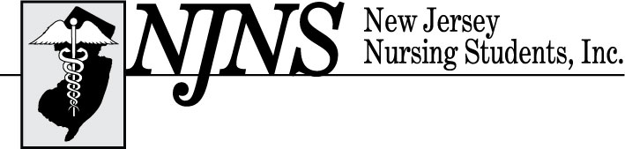

Scholarship Application

CHECKLIST FOR COMPLETE SCHOLARSHIP APPLICATION MAILING

MUST BE POSTMARKED ON OR BEFOREMIDNIGHT January 9, 2026
(Late applications will NOT be considered. You may email Regina Adams at the email address below for confirmation it has been received)

Before mailing your scholarship application to the scholarship chairperson, please review and check (√) responses to the following items and include this form in your mailing. ONLY typed, complete applications will be accepted for consideration by the Scholarship Committee. Emailed applications will not be accepted. To be considered complete, you MUST include the
following:

⁪ Copy of this page

⁪ Completed application with applicant’s signature

⁪ Personal Statement Essay

⁪ Resume

⁪ Photocopied NSNA membership card

⁪ OFFICIAL transcript

⁪ ONE faculty or academic advisor letter of recommendation

⁪ ONE personal (non-relative) recommendation

SEND COMPLETED APPLICATION TO:
Regina Adams, MSN, RN, CNOR
1479 Pennington Road
Trenton, NJ 08618-2694
Email: staff@njnsinc.org
ELIGIBILITY: Applicant must:
- Be a current member of the NSNA – MUST provide a copy of current NSNA membership card
- Be enrolled in an accredited nursing program
- Have completed one clinical course in a nursing program the prepared graduates for practice as a registered nurse
- Submit evidence of academic ability (Transcripts from institution currently enrolled and most recent semester completed)
- Submit one faculty or academic advisor letter of recommendation and one personal (non-relative) recommendation letter
- Provide a personal statement on nursing philosophy, career goals, and what this award means to you

SELECTION AND NOTIFICATION
The New Jersey Nursing Students, Inc. (NJNS) Scholarship Committee will judge all scholarship applications confidentially and without discrimination. Scholarships are awarded at the opening ceremony during our annual state convention on Thursday, February 19, 2026. Must be a registered participant to remain eligible for the scholarship award. An invitation to the opening ceremony will be sent to all scholarship recipients. Recipients will be notified by February 2, 2026. If you have any questions, please contact Regina Adams at NJSNA (609) 883-5335 or email staff@njnsinc.org.
SECTION 1: Background Information
Name: ________________________________________________________________________
Mailing Address: _______________________________________________________________
Phone: ___________________________ Email: ______________________________________
School of Nursing: ______________________________ City: __________________________
Anticipated Graduation Date: _________________________

SECTION 2: Personal Commitments
Marital Status: ☐ Married ☐ Single
Number of dependents (including self): _____
Employment: ☐ Full-time ☐ Part-time ☐Not currently employed

SECTION 3: Resume
Please include a resume (400 word limit) detailing work history, education, honors, awards, certifications, community and professional involvement (NSNA, NJNS, school SNA chapters, and any other professional organization or activities)

National Student Nurses Association: ______________________________________________________
New Jersey Nursing Students, Inc.: ________________________________________________________
School SNA chapter: ___________________________________________________________________
Community involvement: _______________________________________________________________
Other involvement in nursing activities: ____________________________________________________

SECTION 4: Official Transcript
**Please enclose an OFFICIAL transcript**

SECTION 5: Personal Statement Essay
Please attach a typewritten, double-spaced, 12-point font, 300-word essay explaining why you deserve consideration for this scholarship. Personal statement should include nursing philosophy, career goals, and what this award means to you

SECTION 6: Written Recommendations
**Must be sent with scholarship application**
Please include
- One faculty or academic advisor letter of recommendation
- One personal (non-relative) letter of recommendation

SECTION 7: Applicant Certification
I believe I am eligible to receive an NJNS scholarship. I certify that all statements made in this application are complete and accurate. I understand that the decision of NJNS is final and that attendance at the award ceremony is required.

Signature of applicant _________________________________________________

Date______________

